Lab Journal: 5

Date: 25-oct-2023

Student : Haseeb Irfan

Enrollment : 01-131232-029

Computer Programming Lab (Fall-2022)

Teacher: Engr. M Waleed Khan

Department of Software Engineering

Bahria University, Islamabad

|  |  |  |  |  |  |
| --- | --- | --- | --- | --- | --- |
| **Task No:** | **Task Wise Marks** | | **Documentation Marks** | | **Total Marks**  **(20)** |
| **Assigned** | **Obtained** | **Assigned** | **Obtained** |
| 1 | 3 |  | 5 |  |  |
| 2 | 3 |  |
| 3 | 3 |  |
| 4 | 3 |  |
| 5 | 3 |  |

**Comments:**

**Signature**

# Lab No: 2- LOOP STATEMENTS- DO WHILE LOOP

## Introduction

In this lab we learnt about the basics of c ++. We learnt how to use do while statement.

## Tools Used

Microsoft visual studio

## Task 1: Print numbers in descending order.

### Code

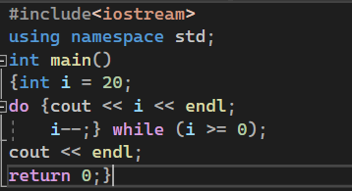

### Program

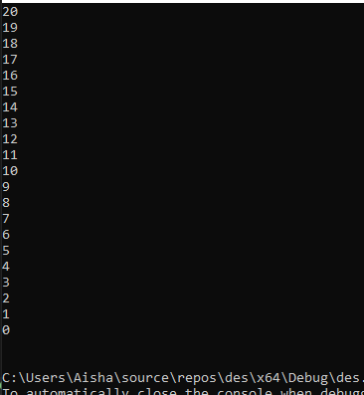

## Task 2: Calculate factorial of a number.

### Code

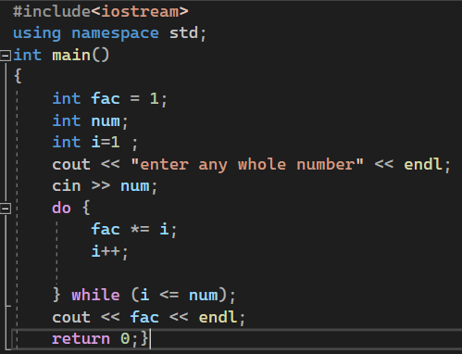

### Program

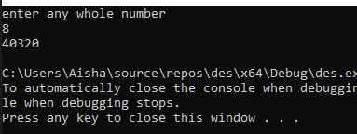

**Task 3: Conversion from decimal to octal number.**

### Code

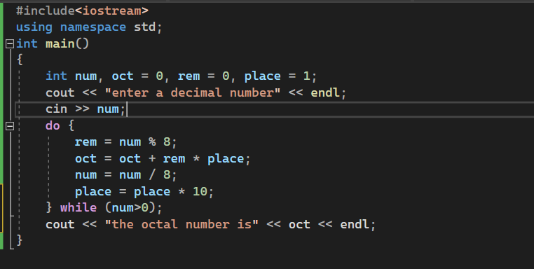

### Program

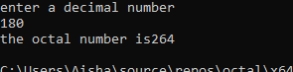

**Task 4: Four-Function Calculator.**

**Code**

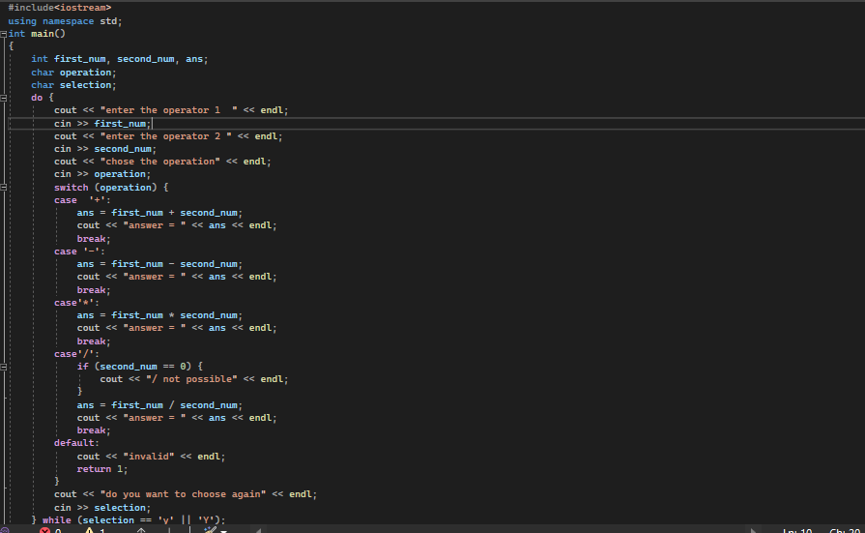

**Program**

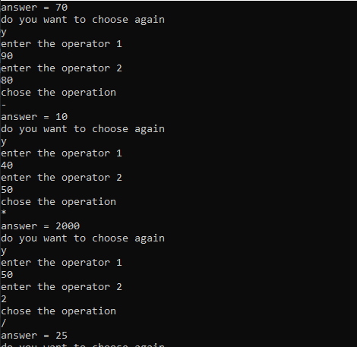

**Task 5: It is necessary for the program to display the following sequence of numbers: 7 14 21 28 35 42 49 56 63 70 77 84 91 98**

**code**

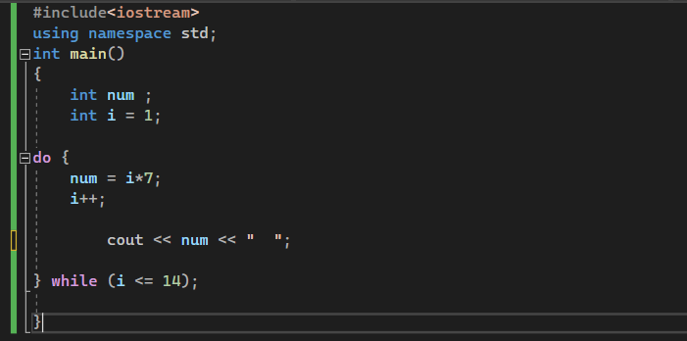

### Program

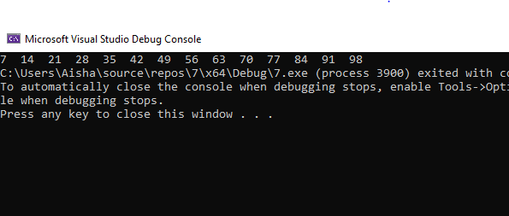

**Task 6: It is necessary to display the following sequence of numbers: 1 2 4 8 16 32 64 128 256 512**

**Code:**

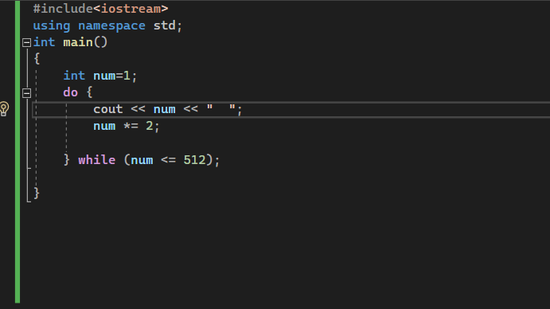

**Program:**

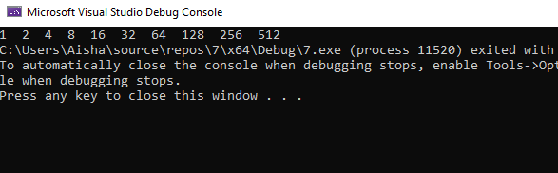

## Conclusion

Understanding of basic concept of do-while loop. In “do-while” loop, the body of loop comes before the test condition. The body of the loop is executed and then the condition is tested.

**LINK**